Toolkit for Marac
Family Intervention Projects (FIPs)
“The Marac has encouraged closer working between the Idvas and the WSOs. Also, it is more likely that Offender Managers will provide enhanced levels of supervision for those perpetrators that are listed at Marac.”
Women Safety Officer, London

Introduction
What is a Multi-Agency Risk Assessment Conference (Marac)?
A Marac is a meeting where information is shared on the highest risk domestic abuse cases between representatives of local police, probation, health, child protection, housing practitioners, Independent Domestic Violence Advisors (Idvas) and other specialists from the statutory and voluntary sectors. After sharing all relevant information they have about a victim, the representatives discuss options for increasing the safety of the victim and turn these into a co-ordinated action plan.

The primary focus of the Marac is to safeguard the adult victim. The Marac will also make links with other fora to safeguard children and manage the behaviour of the perpetrator. At the heart of a Marac is the working assumption that no single agency or individual can see the complete picture of the life of a victim, but all may have insights that are crucial to their safety. The victim does not attend the meeting but is normally represented by an Idva who speaks on their behalf.

Maracs and FIPs
The Marac will help you ensure that domestic abuse victims in families that you support are better protected from further abuse by a coordinated effort from all agencies and organisations. The FIP representative’s role at Marac is to represent the views of your family members at the meeting, to share information relating to the safety of family members and to liaise with partner agencies to ensure that the right services coordinate a response to a family. The Marac helps high risk victims access more resources locally and helps you build relationships with local agencies.

This toolkit includes the practical tools referred to in the SafeLives FIPs Domestic Abuse training. We hope that you can use it whenever you become aware of domestic abuse within a family. The toolkit contains tools to use with victims of domestic abuse to assist them in recognising the dynamics of power and control, some reminders around improving safety as you work with perpetrators, a risk checklist to assist you in recognising high risk domestic abuse and tools to use as you work with clients who need to go through the Marac process.

Domestic abuse may be one of several issues involved in complex cases. We suggest that you consider using the risk checklist with every victim of domestic abuse you work with. However, as FIP key workers you will need to consider carefully which tools are relevant for your families and consider the victim’s safety as and when you use them.

Please consider the following points as you use this toolkit:

- Child protection
Always consider your child protection procedure as you work with domestic abuse.

- The safety of the victim of domestic abuse
Always ask yourself if your planned course of action could put somebody at further risk.

- The safety of the professional
Keep yourself safe and consider the risks posed to you as you work in homes where domestic abuse is ongoing.

- The risks of working with perpetrators
It is easy to be manipulated by perpetrators of abuse, be careful not to collude.

- Use of resources
There will be experts in domestic abuse in your area. Locate them and work in partnership with them when you identify domestic abuse.

Frequently asked questions
Why does a representative from my agency attend?
The Marac will aid you in achieving a joined-up and structured approach to addressing the safety needs of victims of high risk domestic abuse using your service. The kind of partnership working and efficient and effective information sharing that is facilitated by the Marac process would not be achievable if it were not for the meeting. It is therefore important that you attend to provide a realistic overview to action planning and assist the Marac by taking actions to improve the safety of the victim of domestic abuse.

What cases are discussed?
The highest risk cases of domestic abuse are discussed in your Marac. These will have been identified by a practitioner from any agency using an evidence based risk assessment tool (see page 18 for a SafeLives recommended risk checklist). It is recommended that the Marac should initially see the top 10% of cases in your area in terms of risk profile.

What information should my agency bring?
All information shared at the Marac should be relevant and proportionate to the risks faced by the victim of domestic abuse. FIPs will be able to provide information as to the position of the victim and offer advice as to the risks posed to other family members. It may be that the FIP representative will be able to provide safe contact and visit times to partner agencies to improve the safety of intervention with clients.

What actions can we offer?
The actions offered by the FIP representative will usually reflect the work the FIP is already doing with a family. This might involve discussing options, assisting with housing options, risk assessing and signposting on to other services.

What are the legal grounds for sharing information?
Disclosures to Marac are made under the Data Protection Act and the Human Rights Act and Caldicott Guidelines. Relevant information can be shared when it is necessary to prevent a crime, protect the health and/or safety of the victim and/or the rights and freedoms of those who are victims of violence and/or their children. It must be proportionate to the level of risk of harm to a named individual or known household. For further information see the FAQs on disclosure of information at Marac available at: http://www.safelives.org.uk/marac/Disclosure_of_Info_at_Marac_FAQs.pdf

Does the victim need to know they are being discussed at Marac?
Whether you discuss the Marac with your patient depends on who referred the case to Marac.

- If you are the referring agency: It is good practice to discuss the referral with the victim if it is safe to do so. You will need to use your professional judgement to decide whether it is safe.
- If you are not the referring agency: You should check with the referring agency before contacting your client to gather relevant information to ensure it is safe to do so.

There is a grid at the end of this toolkit where you can enter details of your local Marac representatives.

Other Marac toolkits and resources
If you or someone from your agency attends the Marac meeting, you can download a Marac Representative’s Toolkit here: http://www.safelives.org.uk/marac/Toolkit-Marac-representative.pdf. This essential document troubleshoots practical issues around the whole Marac process.

Other frontline Practitioner Toolkits are also available from http://www.safelives.org.uk/marac/Resources_for_people_who_refer_to_Marac.html. These offer a practical introduction to Marac within the context of a professional role. Please signpost colleagues and other agency staff to these toolkits where relevant:

A&E
Ambulance Service
BAMER Services
Children and Young People’s Services
Drug and Alcohol
Education
Fire and Rescue Services
Family Intervention Projects
Health Visitors, School Nurses & Community Midwives
Housing
Independent Domestic Violence Advisors
LGBT Services
Marac Chair
Marac Coordinator
Mental Health Services for Adults
Police Officer
Probation
Social Care Services for Adults
Sexual Violence Services
Specialist Domestic Violence Services
Victim Support
Women’s Safety Officer

For more guidance on the Marac process see the 10 Principles of an Effective Marac: http://www.safelives.org.uk/marac/10_Principles_Oct_2011_full.doc. This forms the basis of the Marac Self Assessment process and national standards for Marac.

FIPs and domestic abuse: A care pathway
The FIP referral process
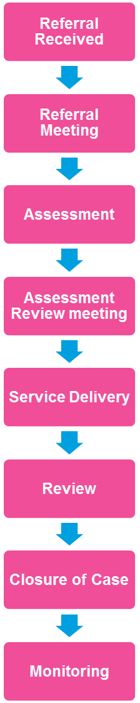
Consider the safety of the adult victim and their children as you use these tools
If domestic abuse is disclosed use the risk checklist
Should this case go to Marac? Use your Marac toolkit.
Use the Power and Control wheels to assist your clients in recognising the dynamics of domestic abuse
Be aware of the risks and safety implications of working with victims and perpetrators of domestic abuse together. Remember the Do’s and Don’ts of perpetrator work.
Power and control wheels

Tactics of men who abuse their partners
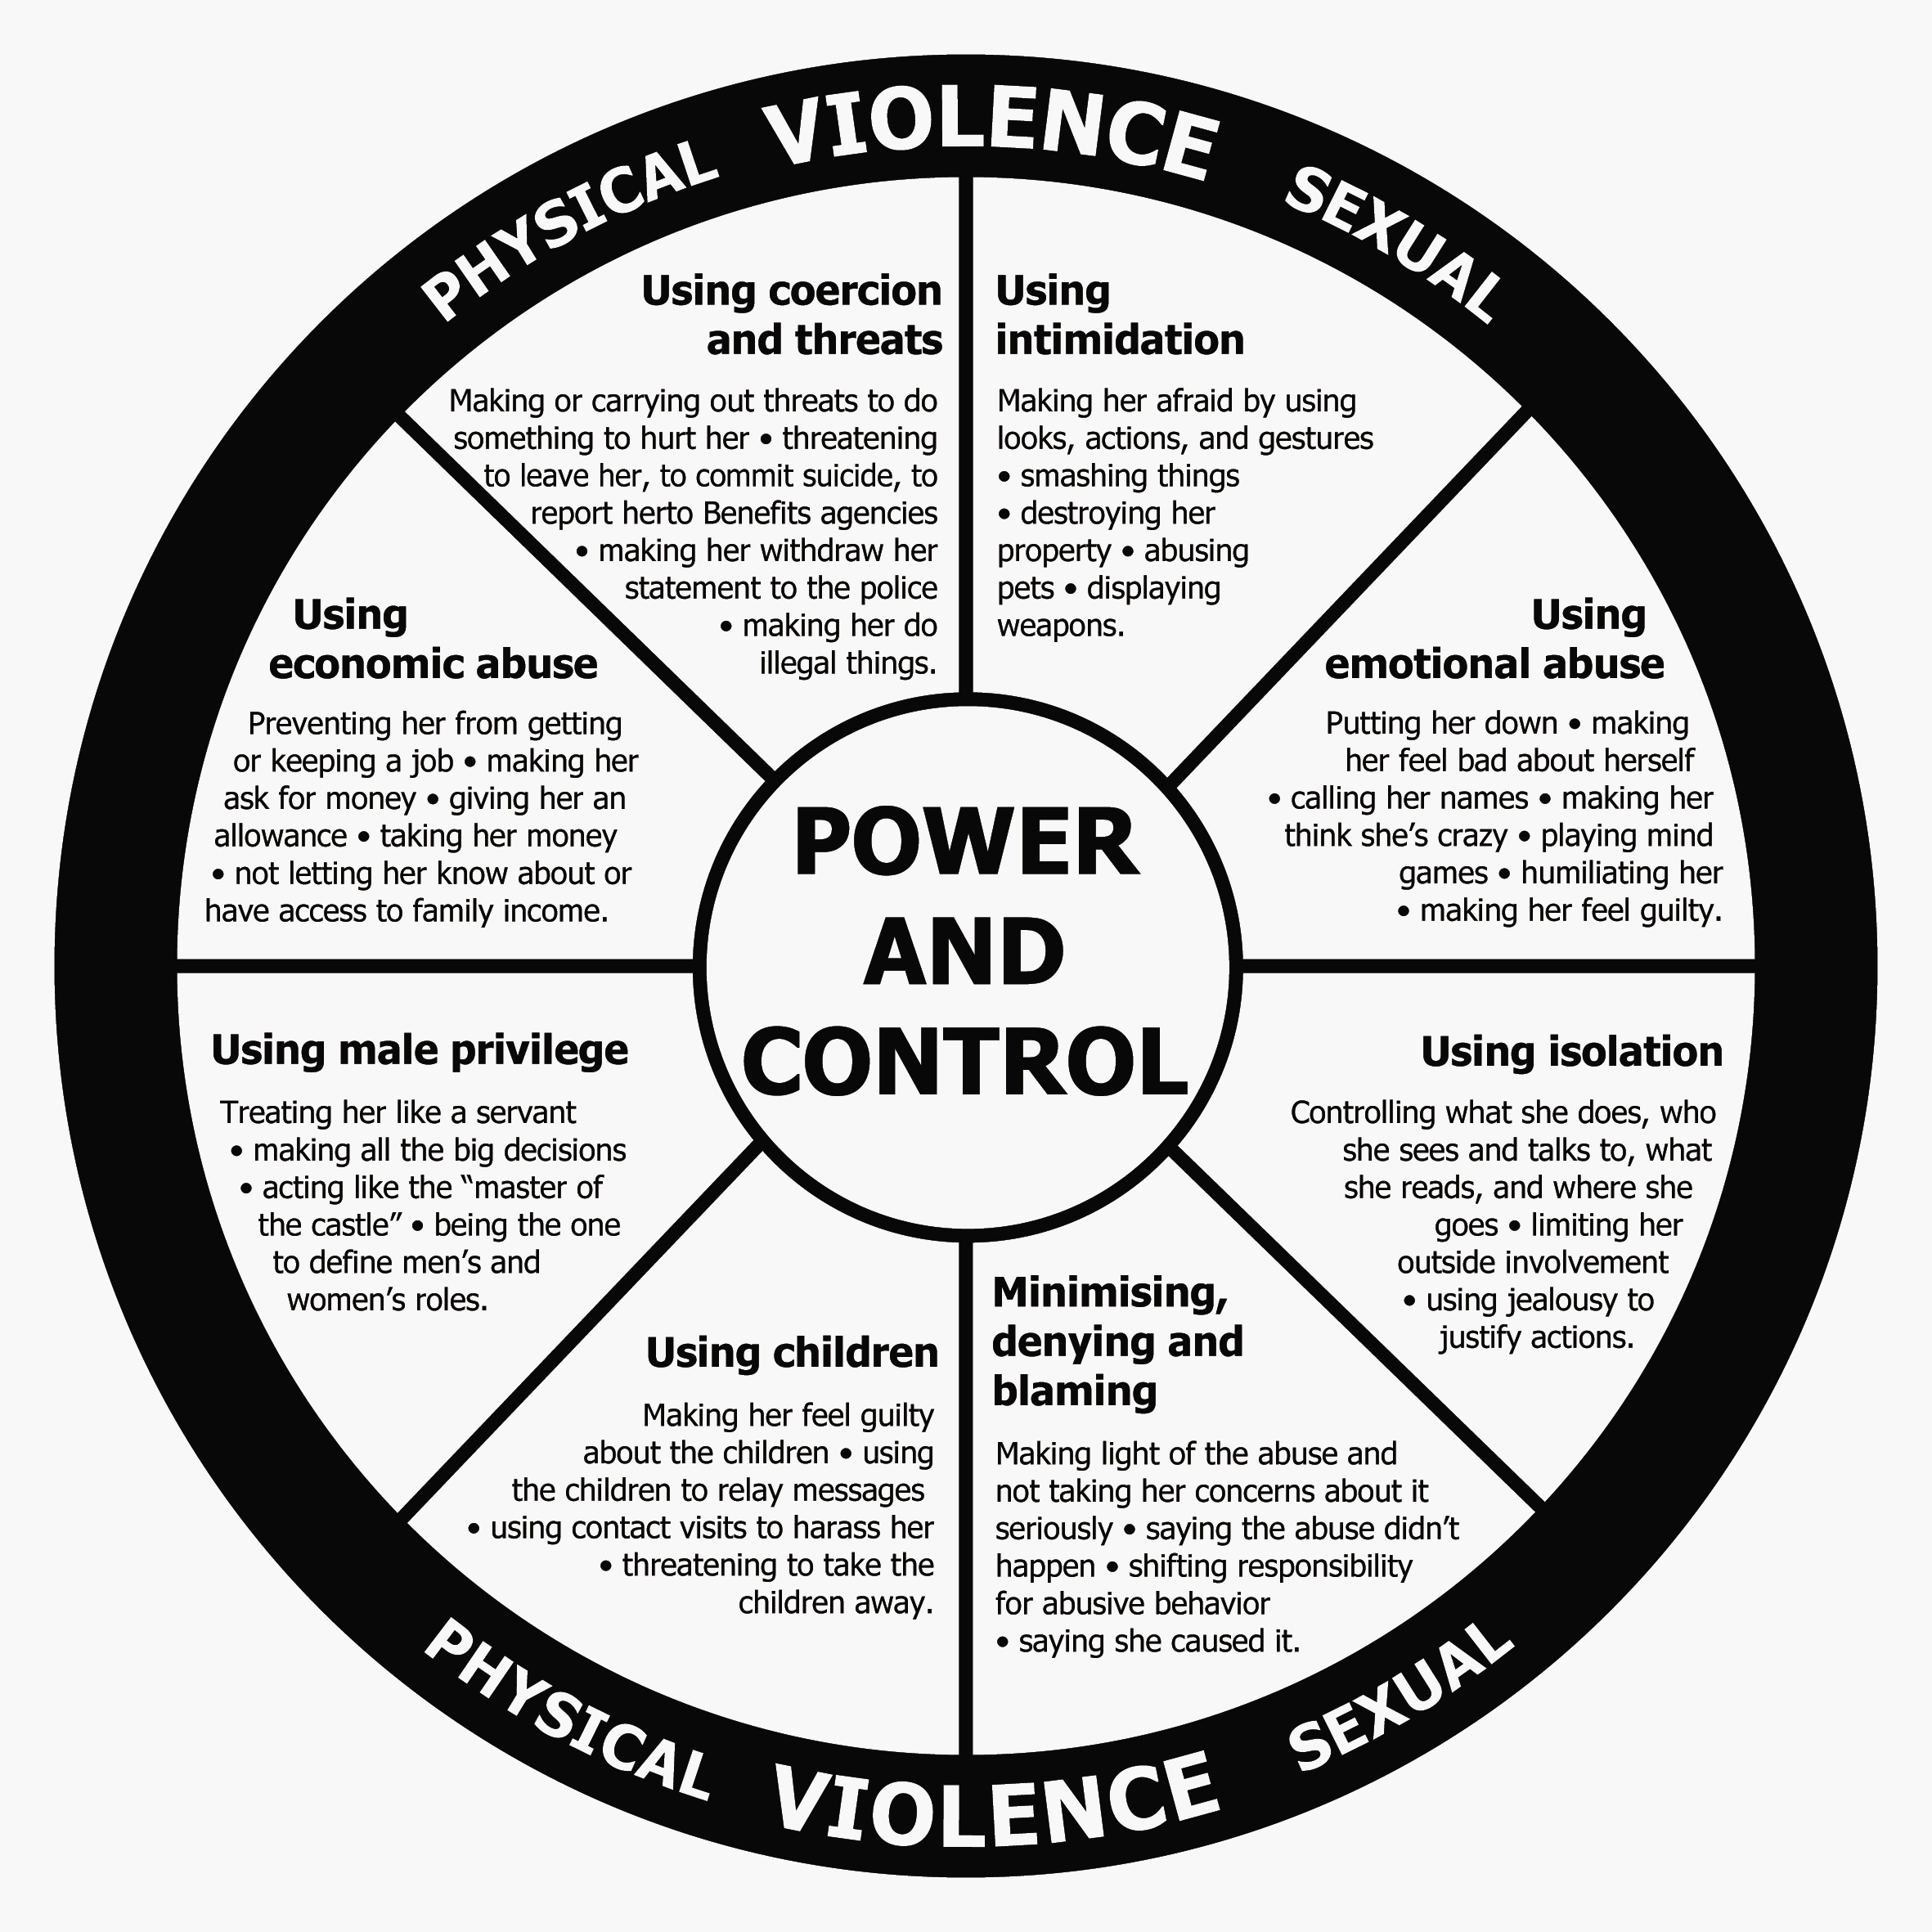
The equality wheel
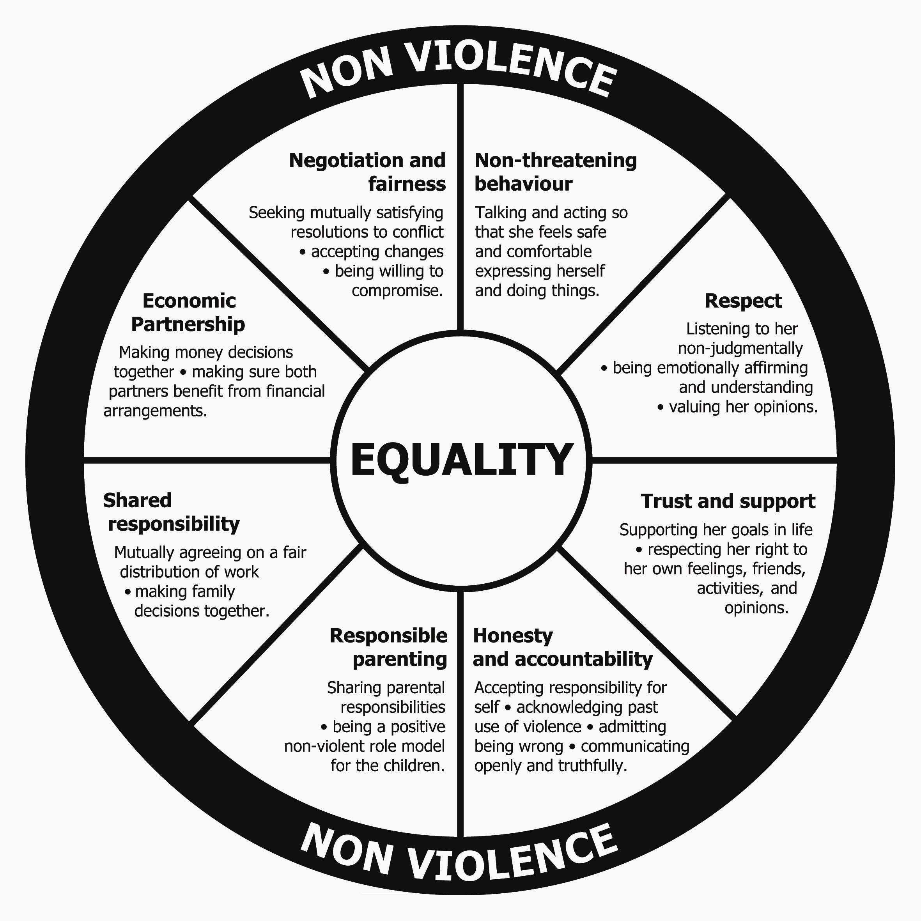
Power and control wheel
The figure below was developed by Dr Sharifa Alkahteeb at the Centre for Children and Families in the Justice System, London, Ontario and is designed for use with Muslim survivors of domestic abuse.
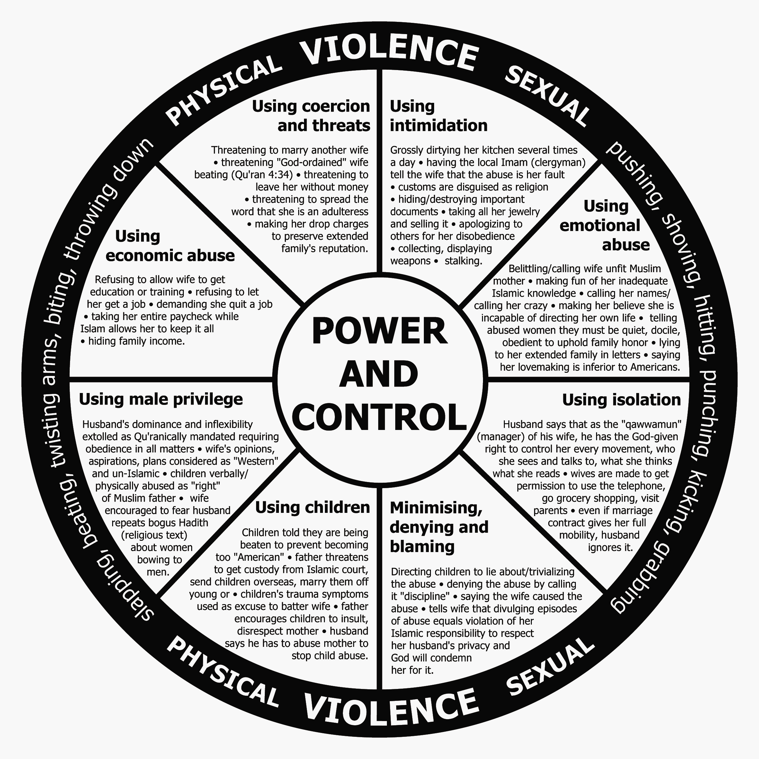
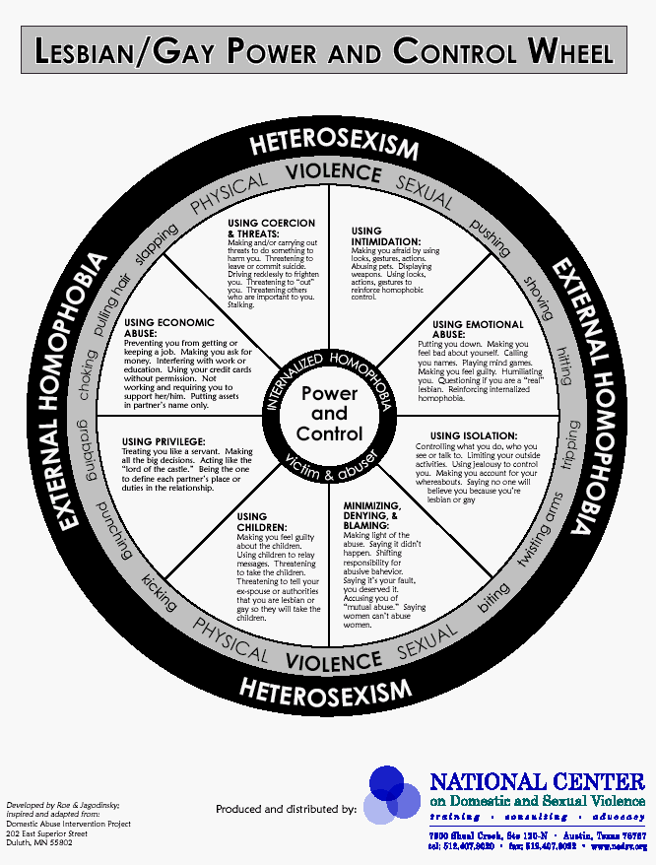
Working with perpetrators
As a FIP key worker there will be occasions where you will be working with perpetrators of abuse and their victims as you manage one family.

Although key to the work of the Family Intervention Project this practice can include additional risks, both to the victim of abuse and to the safety of the worker. You should be aware of these risks as you work with your families.

Consider the following points:

- There is no culture that condones domestic abuse.

If an abuser discloses their behaviour:

DO
- Acknowledge that any form of domestic abuse is wrong and ensure that this message is clear and consistent. Remember that domestic abuse is a crime.
- Acknowledge that the disclosure is an important first step towards stopping their abusive behaviour.
- Affirm any accountability shown by them. Their behaviour is a choice and they can choose to stop.
- Be respectful and empathic but do not collude. Affirm that the use of violence is wrong.
- Offer assistance by way of the Respect phone line number (0845 122 8609)
- Identify the perpetrator programs running in your area and identify them as an option for the abuser. Where programmes aren’t available consider using other services such as Relate or Respect.
- Consider seeking specialist advice from the Probation Service.
- Seek out specialist support for the victim of abuse if their partner is accessing a perpetrator programme.
- Be aware that perpetrators minimise, deny and blame.

DON’T
- Make assumptions. Anyone can be a victim of domestic abuse and anyone can be a perpetrator. Be careful not to stereotype. Domestic abuse occurs across all areas of society, regardless of culture, religion or class.
- Meet the abuser alone. Do make use of any specialist perpetrator services in your area and risk assess before attending an address.
- Discuss the abuse with the couple; try to speak with each party alone.
- Assume that perpetrator programmes will “fix” things. They cannot work in all cases.
- Assume that alcohol and drugs are the cause of domestic abuse; they may escalate situations but will not be the underlying cause.
- Assume that accessing help for alcohol or drug difficulties will stop someone’s violence or abuse. They may need to get help for their substance misuse alongside help for their abusive behaviour.
- Automatically refer to anger management. Remember domestic abuse is not about any loss of control or anger issues.
- Automatically refer to mediation or couples counselling. These can be dangerous. They may not be appropriate if there is inequality in the balance of power between a couple.

Flowcharts

Steps to the Marac process
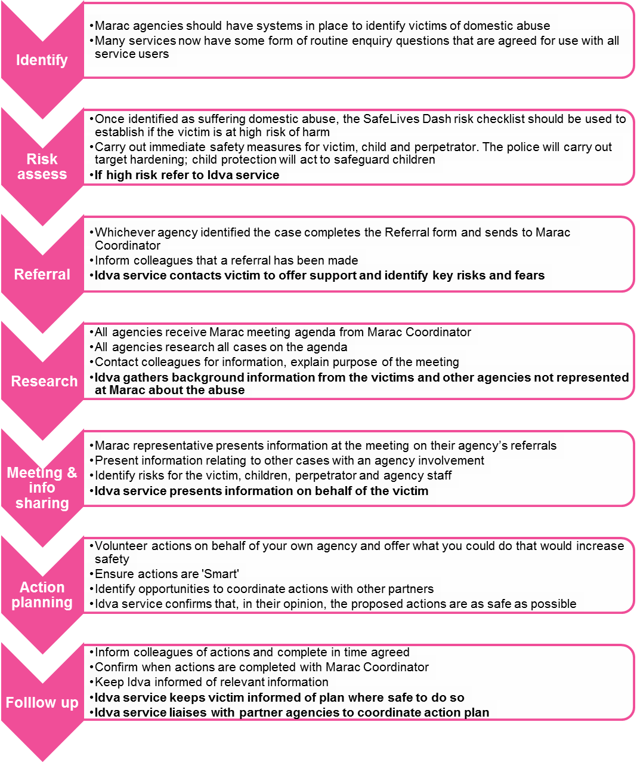
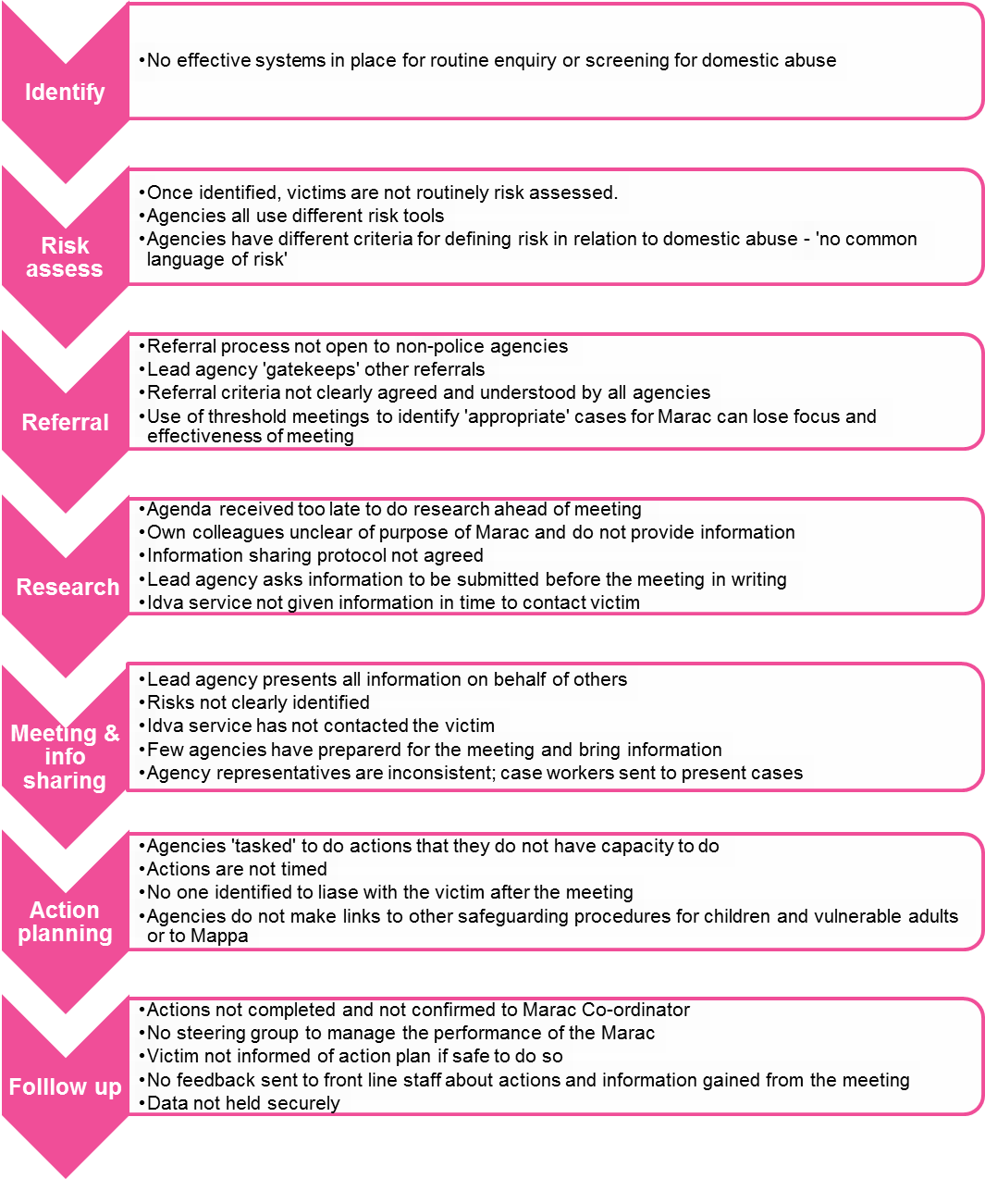
Some common pitfalls

Researching for the Marac
Practice in your agency will differ according to local policy and organisational structure, but below is an outline of the research process for Marac. All the cells in white should be completed by your Marac representative.
Check all addresses you have for victim, perpetrator(s) and children, including any on the agenda.
Check information systems for up-to-date information and flag files as Marac case with date.
Contact key worker involved if necessary to get up-to-date info and complete any appropriate actions in line with domestic violence policy.
Complete research form using records and information from key worker.
Put flag on form (if safe to do so) making a note that Marac took place, the date, and who to contact with queries
Marac representative attends Marac, shares information and agrees actions.
Feed back to key worker any relevant information shared by other agencies and any relevant actions so you can make sure their response to that family is as safe and supportive as it can be and that they consult you if any further incident arises
List of names to be discussed at Marac received from the Marac Co-ordinator (approximately eight working days prior to the meeting).
a
Key worker completes actions and lets Marac representative know when completed.
.

Completed by
Key worker
or Marac representative

Completed by
key worker
or Marac representative

Referring a case to the Marac
Policies on making a referral to your particular Marac will be available locally but here is an outline of the process.
Key worker completes Risk Identification Checklist (page 19) with the client. Alternatively, makes a clinical judgement of level of risk faced by client or passes up to Marac representative to do so.
If risk level meets Marac threshold refer to manager to discuss safety options to put in place now. Fill out referral form (page 23) and hand to Marac representative.
Notify your representative once those actions are completed.
Disclosure of domestic abuse is made to key worker. At this point key worker will check with domestic violence policy and complete appropriate actions.

If does not meet the Marac threshold: continue to complete appropriate actions and support accordingly to policy.
END

Marac representative/key worker involved fills out as much of the research form (page 24) as possible and takes it to the meeting. Other agencies do the same and information is shared at the meeting.

Referral made to Marac

Following the Marac meeting the Marac rep will inform you of any information that was shared which could have an impact on your response to the victim/perpetrator(s). Also you might have been assigned actions to help improve the safety of the victim and any children, such as introducing the client to the Idva.

Marac meeting

SafeLives Dash risk checklist
Quick start guidance
You may be looking at this checklist because you are working in a professional capacity with a victim of domestic abuse. These notes are to help you understand the significance of the questions on the checklist. Domestic abuse can take many forms but it is usually perpetrated by men towards women in an intimate relationship such as boyfriend/girlfriend, husband/wife. This checklist can also be used for lesbian, gay, bisexual relationships and for situations of ‘honour’-based violence or family violence. Domestic abuse can include physical, emotional, mental, sexual or financial abuse as well as stalking and harassment. They might be experiencing one or all types of abuse; each situation is unique. It is the combination of behaviours that can be so intimidating. It can occur both during a relationship or after it has ended.

The purpose of the risk checklist is to give a consistent and simple tool for practitioners who work with adult victims of domestic abuse in order to help them identify those who are at high risk of harm and whose cases should be referred to a Marac meeting in order to manage their risk. If you are concerned about risk to a child or children, you should make a referral to ensure that a full assessment of their safety and welfare is made.

The risk checklist should be introduced to the victim within the framework of your agency’s:
- Confidentiality Policy
- Information Sharing Policy and Protocols
- Marac Referral Policies and Protocols

Before you begin to ask the questions in the risk checklist:
- Establish how much time the victim has to talk to you: is it safe to talk now? What are safe contact details?
- Establish the whereabouts of the perpetrator and children
- Explain why you are asking these questions and how it relates to the Marac

While you are asking the questions in the risk checklist:
- Identify early on who the victim is frightened of – ex-partner/partner/family member
- Use gender neutral terms such as partner/ex-partner. By creating a safe, accessible environment LGBT victims accessing the service will feel able to disclose both domestic abuse and their sexual orientation or gender identity.

Revealing the results of the risk checklist to the victim
Telling someone that they are at high risk of serious harm or homicide may be frightening and overwhelming for them to hear. It is important that you state what your concerns are by using the answers they gave to you and your professional judgement. It is then important that you follow your area’s protocols when referring to Marac and Children’s Services. Equally, identifying that someone is not currently high risk needs to be managed carefully to ensure that the person doesn’t feel that their situation is being minimised and that they don’t feel embarrassed about asking for help. Explain that these factors are linked to homicide and serious harm and that if s/he experiences any of them in future, that they should get back in touch with your service or with the emergency services on 999 in an immediate crisis.

Please pay particular attention to a practitioner’s professional judgement in all cases. The results from a checklist are not a definitive assessment of risk. They should provide you with a structure to inform your judgement and act as prompts to further questioning, analysis and risk management whether via a Marac or in another way.

The responsibility for identifying your local referral threshold rests with your local Marac.

Resources
Be sure that you have an awareness of the safety planning measures you can offer, both within your own agency and other agencies. Be familiar with local and national resources to refer the victim to, including specialist services. The following websites and contact details may be useful to you:

- National Domestic Violence Helpline (tel: 0808 2000 247) for assistance with refuge accommodation and advice.
- ‘Honour’ Helpline (tel: 0800 5999247) for advice on forced marriage and ‘honour’ based violence
- Sexual Assault Referral Centres (web: http://www.rapecrisis.org.uk/Referralcentres2.php) for details on SARCs and to locate your nearest centre.
- Broken Rainbow (tel: 08452 604460 / web: www.broken-rainbow.org.uk for advice for LGBT victims) for advice and support for LGBT victims of domestic abuse.

Asking about types of abuse and risk factors

Physical abuse
We ask about physical abuse in questions 1, 10, 11, 13, 15, 18, 19 and 23.

- Physical abuse can take many forms from a push or shove to a punch, use of weapons, choking or strangulation.
- You should try and establish if the abuse is getting worse, or happening more often, or the incidents themselves are more serious. If your client is not sure, ask them to document how many incidents there have been in the last year and what took place. They should also consider keeping a diary marking when physical and other incidents take place.
- Try and get a picture of the range of physical abuse that has taken place. The incident that is currently being disclosed may not be the worst thing to have happened.
- The abuse might also be happening to other people in their household, such as their children or siblings or elderly relatives.
- Sometimes violence will be used against a family pet.
- If an incident has just occurred the victim should call 999 for assistance from the police. If the victim has injuries they should try and get them seen and documented by a health professional such as a GP or A&E nurse.

Sexual abuse
We ask about whether the victim is experiencing any form of sexual abuse in question 16.

- Sexual abuse can include the use of threats, force or intimidation to obtain sex, deliberately inflicting pain during sex, or combining sex and violence and using weapons.
- If the victim has suffered sexual abuse you should encourage them to get medical attention and to report this to the police. See above for advice on finding a Sexual Assault Referral Centre which can assist with medical and legal investigations.

Coercion, threats and intimidation
Coercion, threats and intimidation are covered in questions 2, 3, 6, 8, 14, 17, 18, 19, 23 and 24.

- It is important to understand and establish: the fears of the victim/victims in relation to what the perpetrator/s may do; who they are frightened of and who they are frightened for (e.g. children/siblings). Victims usually know the abuser’s behaviour better than anyone else which is why this question is significant.
- In cases of ‘honour’ based violence there may be more than one abuser living in the home or belonging to the wider family and community. This could also include female relatives.
- Stalking and harassment becomes more significant when the abuser is also making threats to harm themselves, the victim or others. They might use phrases such as “If I can’t have you no one else can…”
- Other examples of behaviour that can indicate future harm include obsessive phone calls, texts or emails, uninvited visits to the victim’s home or workplace, loitering and destroying/vandalising property.
- Advise the victim to keep a diary of these threats, when and where they happen, if anyone else was with them and if the threats made them feel frightened.
- Separation is a dangerous time: establish if the victim has tried to separate from the abuser or has been threatened about the consequences of leaving. Being pursued after separation can be particularly dangerous.
- Victims of domestic abuse sometimes tell us that the perpetrators harm pets, damage furniture and this alone makes them frightened without the perpetrator needing to physically hurt them. This kind of intimidation is common and often used as a way to control and frighten.
- Some perpetrators of domestic abuse do not follow court orders or contact arrangements with children. Previous violations may be associated with an increase in risk of future violence.
- Some victims feel frightened and intimidated by the criminal history of their partner/ex-partner. It is important to remember that offenders with a history of violence are at increased risk of harming their partner, even if the past violence was not directed towards intimate partners or family members, except for ‘honour’-based violence, where the perpetrator(s) will commonly have no other recorded criminal history.

Emotional abuse and isolation
We ask about emotional abuse and isolation in questions 4, 5 and 12. This can be experienced at the same time as the other types of abuse. It may be present on its own or it may have started long before any physical violence began. The result of this abuse is that victims can blame themselves and, in order to live with what is happening, minimise and deny how serious it is. As a professional you can assist the victim in beginning to consider the risks the victim and any children may be facing.

- The victim may be being prevented from seeing family or friends, from creating any support networks or prevented from having access to any money.
- Victims of ‘honour’ based violence talk about extreme levels of isolation and being ‘policed’ in the home. This is a significant indicator of future harm and should be taken seriously.
- Due to the abuse and isolation being suffered victims feel like they have no choice but to continue living with the abuser and fear what may happen if they try and leave. This can often have an impact on the victim’s mental health and they might feel depressed or even suicidal.
- Equally the risk to the victim is greater if their partner/ex-partner has mental health problems such as depression and if they abuse drugs or alcohol. This can increase the level of isolation as victims can feel like agencies won’t understand and will judge them. They may feel frightened that revealing this information will get them and their partner into trouble and, if they have children, they may worry that they will be removed. These risks are addressed in questions 21 & 22.

Children and pregnancy
Questions 7, 9 and 18 refer to being pregnant and children and whether there is conflict over child contact.

- The presence of children including stepchildren can increase the risk of domestic abuse for the mother. They too can get caught up in the violence and suffer directly.
- Physical violence can occur for the first time or get worse during pregnancy or for the first few years of the child’s life. There are usually lots of professionals involved during this time, such as health visitors or midwives, who need to be aware of the risks to the victim and children, including an unborn child.
- The perpetrator may use the children to have access to the victim, abusive incidents may occur during child contact visits or there may be a lot of fear and anxiety that the children may be harmed.
- Please follow your local Child Protection Procedures and Guidelines for identifying and making referrals to Children’s Services.

Economic abuse
Economic abuse is covered in question 20.

- Victims of domestic abuse often tell us that they are financially controlled by their partners/ex-partners. Consider how the financial control impacts on the safety options available to them. For example, they may rely on their partner/ex-partner for an income or do not have access to benefits in their own right. The victim might feel like the situation has become worse since their partner/ex-partner lost their job.
- The Citizens Advice Bureau or the local specialist domestic abuse support service will be able to outline to the victim the options relating to their current financial situation and how they might be able to access funds in their own right.

Additional versions of the Dash risk form
If you are a professional working with domestic abuse and would like to know more about the Risk Identification Checklist you can find the following publications on our website:

SafeLives Dash risk checklist for the identification of high risk cases of domestic abuse, stalking and honour based violence http://www.safelives.org.uk/dvservices/RIC_and_severity_of_abuse_grid_and_IDVA_practice_guidance.pdf

This is a helpful guide for Idvas or practitioners new to the risk checklist and who want to become more familiar and confident in managing the process. It takes you through the process of completing the risk checklist with your client and provides detail on why and how to ask each question. This guide also provides supplementary questions to gather additional detail about each risk factor and provides general safety planning advice.

It includes the Severity of abuse grid (Sag). The Sag gives practitioners the chance to profile the domestic abuse in more detail and identify significant concerns which may be relevant to include in a safety plan or share at a Marac.

SafeLives-Dash risk checklist – without guidance http://www.safelives.org.uk/marac/RIC_without_guidance.doc
This is a basic version of the risk checklist to download and use in everyday practice.

SafeLives-Dash risk checklist – Frequently Asked Questions http://www.safelives.org.uk/marac/RIC_FAQs.pdf
This addresses a number of practical questions relating to the use of the checklist.

We also have a library of resources and information about training for frontline practitioners at http://www.safelives.org.uk/marac/Information_about_Maracs.html

SafeLives Dash risk checklist
Aim of the form
- To help front line practitioners identify high risk cases of domestic abuse, stalking and ‘honour’-based violence.
- To decide which cases should be referred to Marac and what other support might be required. A completed form becomes an active record that can be referred to in future for case management.
- To offer a common tool to agencies that are part of the Marac process and provide a shared understanding of risk in relation to domestic abuse, stalking and ‘honour’-based violence.
- To enable agencies to make defensible decisions based on the evidence from extensive research of cases, including domestic homicides and ‘near misses’, which underpins most recognised models of risk assessment.

How to use the form
Before completing the form for the first time we recommend that you read the full practice guidance and FAQs. These can be downloaded from: http://www.safelives.org.uk/marac/RIC_for_Marac.html. Risk is dynamic and can change very quickly. It is good practice to review the checklist after a new incident.
Recommended referral criteria to Marac

- Professional judgement: if a professional has serious concerns about a victim’s situation, they should refer the case to Marac. There will be occasions where the particular context of a case gives rise to serious concerns even if the victim has been unable to disclose the information that might highlight their risk more clearly. This could reflect extreme levels of fear, cultural barriers to disclosure, immigration issues or language barriers particularly in cases of ‘honour’-based violence. This judgement would be based on the professional’s experience and/or the victim’s perception of their risk even if they do not meet criteria 2 and/or 3 below.

- ‘Visible High Risk’: the number of ‘ticks’ on this checklist. If you have ticked 14 or more ‘yes’ boxes the case would normally meet the Marac referral criteria.

- Potential Escalation: the number of police callouts to the victim as a result of domestic violence in the past 12 months. This criterion can be used to identify cases where there is not a positive identification of a majority of the risk factors on the list, but where abuse appears to be escalating and where it is appropriate to assess the situation more fully by sharing information at Marac. It is common practice to start with 3 or more police callouts in a 12 month period but this will need to be reviewed depending on your local volume and your level of police reporting.

Please pay particular attention to a practitioner’s professional judgement in all cases. The results from a checklist are not a definitive assessment of risk. They should provide you with a structure to inform your judgement and act as prompts to further questioning, analysis and risk management whether via a Marac or in another way.

The responsibility for identifying your local referral threshold rests with your local Marac.

What this form is not
This form will provide valuable information about the risks that children are living with but it is not a full risk assessment for children. The presence of children increases the wider risks of domestic violence and step children are particularly at risk. If risk towards children is highlighted you should consider what referral you need to make to obtain a full assessment of the children’s situation.
SafeLives Dash risk checklist for use by Idvas and other non-police agencies for identification of risks when domestic abuse, ‘honour’- based violence and/or stalking are disclosed

Please explain that the purpose of asking these questions is for the safety and protection of the individual concerned.  Tick the box if the factor is present. Please use the comment box at the end of the form to expand on any answer.  It is assumed that your main source of information is the victim. If this is not the case, please indicate in the right hand column | YES | NO | DON’T KNOW | State source of info if not the victim  (eg police officer)
- Has the current incident resulted in injury?  Please state what and whether this is the first injury. | ☐ | ☐ | ☐
- Are you very frightened?  Comment: | ☐ | ☐ | ☐
- What are you afraid of? Is it further injury or violence?  Please give an indication of what you think [name of abuser(s)] might do and to whom, including children.  Comment: | ☐ | ☐ | ☐
- Do you feel isolated from family/friends?  Ie, does [name of abuser(s)] try to stop you from seeing  friends/family/doctor or others?  Comment: | ☐ | ☐ | ☐
- Are you feeling depressed or having suicidal thoughts? | ☐ | ☐ | ☐
- Have you separated or tried to separate from [name of abuser(s)] within the past year? | ☐ | ☐ | ☐
- Is there conflict over child contact? | ☐ | ☐ | ☐
- Does [name of abuser(s)] constantly text, call, contact, follow, stalk or harass you?  Please expand to identify what and whether you believe that this is done deliberately to intimidate you? Consider the context and behaviour of what is being done. | ☐ | ☐ | ☐
- Are you pregnant or have you recently had a baby (within the last 18 months)? | ☐ | ☐ | ☐
- Is the abuse happening more often?

- Is the abuse getting worse? | ☐ | ☐ | ☐
- Does [name of abuser(s)] try to control everything you do and/or are they excessively jealous?  For example: in terms of relationships; who you see; being ‘policed’ at home; telling you what to wear. Consider ‘honour’-based violence (HBV) and specify behaviour. | ☐ | ☐ | ☐
- Has [name of abuser(s)] ever used weapons or objects to hurt you? | ☐ | ☐ | ☐
Tick the box if the factor is present. Please use the comment box at the end of the form to expand on any answer. | YES | NO | DON’T KNOW | State source of info if not the victim
- Has [name of abuser(s)] ever threatened to kill you or someone else and you believed them?  If yes, tick who:  You ☐  Children ☐  Other (please specify) ☐ | ☐ | ☐ | ☐
- Has [name of abuser(s)] ever attempted to strangle / choke / suffocate / drown you? | ☐ | ☐ | ☐
- Does [name of abuser(s)] do or say things of a sexual nature that make you feel bad or that physically hurt you or someone else?  If someone else, specify who. | ☐ | ☐ | ☐
- Is there any other person who has threatened you or who you are afraid of?  If yes, please specify whom and why. Consider extended family if HBV. | ☐ | ☐ | ☐
- Do you know if [name of abuser(s)] has hurt anyone else?  Consider HBV. Please specify whom, including the children, siblings or elderly relatives:  Children ☐  Another family member ☐  Someone from a previous relationship ☐  Other (please specify) ☐ | ☐ | ☐ | ☐
- Has [name of abuser(s)] ever mistreated an animal or the family pet? | ☐ | ☐ | ☐
- Are there any financial issues?  For example, are you dependent on [name of abuser(s)] for money/have they recently lost their job/other financial issues? | ☐ | ☐ | ☐
- Has [name of abuser(s)] had problems in the past year with drugs (prescription or other), alcohol or mental health leading to problems in leading a normal life?  If yes, please specify which and give relevant details if known.  Drugs ☐  Alcohol ☐  Mental health ☐ | ☐ | ☐ | ☐
- Has [name of abuser(s)] ever threatened or attempted suicide? | ☐ | ☐ | ☐
- Has [name of abuser(s)] ever broken bail/an injunction and/or formal agreement for when they can see you and/or the children?  You may wish to consider this in relation to an ex-partner of the perpetrator if relevant.  Bail conditions ☐  Non Molestation/Occupation Order ☐  Child contact arrangements ☐  Forced Marriage Protection Order ☐  Other ☐ | ☐ | ☐ | ☐
- Do you know if [name of abuser(s)] has ever been in trouble with the police or has a criminal history?  If yes, please specify:  Domestic abuse ☐  Sexual violence ☐  Other violence ☐  Other ☐ | ☐ | ☐ | ☐
Total ‘yes’ responses

For consideration by professional
Is there any other relevant information (from victim or professional) which may increase risk levels? Consider victim’s situation in relation to disability, substance misuse, mental health issues, cultural / language barriers, ‘honour’- based systems, geographic isolation and minimisation.
Are they willing to engage with your service? Describe.
Consider abuser’s occupation / interests. Could this give them unique access to weapons? Describe.
What are the victim’s greatest priorities to address their safety?

Do you believe that there are reasonable grounds for referring this case to Marac? |  |  | Yes ☐  No ☐
If yes, have you made a referral? |  |  | Yes ☐  No ☐
Signed |  |  | Date
Do you believe that there are risks facing the children in the family? |  |  | Yes ☐  No ☐
If yes, please confirm if you have made a referral to safeguard the children? |  | Yes ☐  No ☐ | Date referral made
Signed |  |  | Date
Name

Practitioner’s notes

This document reflects work undertaken by SafeLives in partnership with Laura Richards, Consultant Violence Adviser to ACPO. We would like to thank Advance, Blackburn with Darwen Women’s Aid and Berkshire East Family Safety Unit and all the partners of the Blackpool Marac for their contribution in piloting the revised checklist without which we could not have amended the original SafeLives risk identification checklist. We are very grateful to Elizabeth Hall of CAFCASS and Neil Blacklock of Respect for their advice and encouragement and for the expert input we received from Jan Pickles, Dr Amanda Robinson and Jasvinder Sanghera.
Marac referral form
Marac referrals should be sent by secure email or other secure method.

Referring agency
Contact name(s)
Telephone / Email
Date
Victim name |  |  | Victim DOB
Address
Telephone number |  |  | Is this number safe to call? | Y / N
Please insert any relevant contact information, eg times to call
Diversity data (if known) |  | B&ME ☐ Disabled ☐  LGBT ☐ Gender M / F
Perpetrator(s) name |  |  | Perpetrator(s) DOB
Perpetrator(s) address |  |  | Relationship to victim

Children (please add extra rows if necessary) | DOB | Relationship to victim | Relationship to perpetrator | Address | School  (If known)

Reason for referral / additional information
Professional judgement | Y / N |  | Visible high risk (14 ticks or more on SafeLives - Dash risk assessment) |  |  | Y / N
Potential escalation (3 or more incidents reported to the Police in the past 12 months) | Y / N |  | Marac repeat (further incident identified within twelve months from the date of the last referral) |  |  | Y / N
If yes, please provide the date listed / case number (if known)
Is the victim aware of Marac referral? | Y / N |  | If no, why not?
Has consent been given? | Y / N
Who is the victim afraid of? (to include all potential threats, and not just primary perpetrator)
Who does the victim believe it safe to talk to?
Who does the victim believe it not safe to talk to?
Has the victim been referred to any other Marac previously? | Y / N |  | If yes where / when?

Research form for Marac
Name and agency
Telephone / Email
Date
Victim name
Victim DOB
Victim address
Marac case number (from agenda)

 |  | Please insert any changes / errors / other information (eg aliases or nicknames) below
Are the victim details on the Marac list accurate? | Y / N
Are the children(s) details on the Marac list accurate? | Y / N
Are the perpetrator details on the Marac list accurate? | Y / N

Note records of last sightings, meetings or phone calls
Note recent attitude, behaviour and demeanour, including changes
Highlight any relevant information that relates to any of the risk indicators on the checklist (eg the pattern of abuse, isolation, escalation, victim’s greatest fear etc)
Other information (eg actions already taken by agency to address victim’s safety)
What are the victim’s greatest priorities to address their safety?
Who is the victim afraid of? Include all potential threats, and not just primary perpetrator
Who does the victim believe it safe to talk to?
Who does the victim believe it not safe to talk to?

Contact details for Marac representatives
Agency | Name of Marac representative & deputy | Contact details

To see the FIP Referral Process in more detail please refer to the FIP’s Training Manual (page 6)
www.respect.uk.net/data/files/dv_guide_for_healthcare_professionals.pdf
For further information about Marac please refer to the 10 Principles of an Effective Marac: http://www.SafeLives.org.uk/marac/10_Principles_Oct_2011_full.doc
Note: This checklist is consistent with the ACPO endorsed risk assessment model DASH 2009 for the police service.

